Logic Design Lab
Lab Report

17/2/2026

Table of Contents
Table of Figures 3
Table of Tables 4
I - Introduction 5
II – Equipment 6
III – Pre-Lab 7
IV – Experiment 8
A – Implementing a 2-bit Incrementor/Decrementor 8
B – Implementing a Teacher Grading System 9
C. Building our grading system in a Quartus II project 10
V – Theory 11
VI – Conclusion 12

Table of Figures
Figure 1: Logic diagram of X and Y 11
Figure 2: Quartus II schematic of the Incrementor/Decrementor circuit 11
Figure 3: Quartus II simulation of the Incrementor/Decrementor 12
Figure 4: Incrementor/Decrementor Diagram 13
Figure 5: Circuit diagram of the grade calculating program 15
Figure 6: Implementation of experiment B 16
Figure 7: Successful simulation of the design 16
Figure 8: Circuit diagram of the grade calculating program from 0 to 20 18

Table of Tables
Table 1: Truth table of a Decrementer and an Incrementer of 2 bits 7
Table 2: Truth table of an incrementor 7
Decrementor: (output = input -1)Table 3: Truth table of a decrementor 8
Table 5: Incrementor/Decrementor Truth Table 10
Table 6: Truth table of the grading system 14
Table 7: K-map of D₁ 14
Table 8: K-map of X 15
Table 9: Truth table for grading system from 0 to 20 17

I - Introduction
An Incrementor (INC)/Decrementor (DEC) is an important building block in many digital systems such as the address generation unit of microcontrollers and microprocessors. This experiment studies Incrementors and Decrementors by analyzing their functioning. Specifically, this experiment implemented a 2-bit Incrementor/Decrementor, and a teacher grading system that used incrementation. Implementation was preceded by the logic analysis of each problem, output equation derivation, and logic diagram design. Finally, each system was implemented through a logic circuit set up on the breadboard of the analog digital trainer, using the proper ICs. The experiment was preceded by a pre-lab preparation that provides the background needed to apply it. And followed by a Quartus II project implementation of the grading system to validate results, and a theory section that aims to generalize the implementation of incrementors to building n-bit incrementors.

II – Equipment
- Analog Digital Trainer
- Connecting Wires
- Quartus II
- 74LS86
- 74LS00

III – Pre-Lab
In line of preparation for this lab experiment, the following pre-lab preparation was done.

- An incrementor circuit embedded in digital systems is responsible for increasing a binary value by 1(output = input +1).

- A Decrementor Circuit decreases the binary value by 1 (output = input -1)

- Incrementors are commonly used in Program Counter (PC), loop counters, timers, and especially in units specialized in instruction sequencing in CPUs and microcontrollers.

- Incrementors implement basic arithmetic (+1) efficiently and are the most essential for address progression, sequencing, and counting, making them fundamental components of the CPUs, control logic, and counters, as a result they are considered building blocks in digital design.

Table 1: Truth table of a Decrementer and an Incrementer of 2 bits
Number | Increment  Result | Decrement  Result
00 | 01 | 11
01 | 10 | 00
10 | 11 | 01
11 | 00 | 10
Let the inputs be A (MSB) and B (LSB). Outputs are X (MSB) and Y (LSB).
- Incrementor: (output = input +1)
Table 2:Truth table of an incrementor
Number | X | Y
00 | 0 | 1
01 | 1 | 0
10 | 1 | 1
11 | 0 | 0

So, Y is 1 when B = 0: Y= B’
X=1 at 01 and 10
Then, X= A’B +AB’:
X = A ⊕ B

- Decrementor: (output = input -1)
Table 3: Truth table of a decrementor
Number | X | Y
00 | 1 | 1
01 | 0 | 0
10 | 0 | 1
11 | 1 | 0
Similarly to the Incrementor Y here is 1 when B=0: Y= B’

But X=1 at 00 and 11:
X= A’B’ +AB
X = A ⊙ B

1. 4 Bits are needed because the maximum grade is 10 which in binary is 1010₂ ‎ which needs at least 4 bits to be presented.

2. To determine if a number is odd in binary we only need to check the LSB if it’s ‎ ‎ 1 then then the number is odd.

3. - If the grade that is odd and passing is not equal to 5 then we decrement by 1, ‎ but if it is 5, we keep it untouched.
- If the grade is odd and failing, we decrement it by 1.
- if the grade is even, we keep it untouched.

4. The Green LED should be 1 when the input = output (no change)
The Red LED should be 1 when input ≠ output (a change happened)

5.
Table 4:Truth table of experiment B
A | B | C | D | A1 | B1 | C1 | D1 | X
0 | 0 | 0 | 0 | 0 | 0 | 0 | 0 | 0
0 | 0 | 0 | 1 | 0 | 0 | 0 | 0 | 1
0 | 0 | 1 | 0 | 0 | 0 | 1 | 0 | 0
0 | 0 | 1 | 1 | 0 | 0 | 1 | 0 | 1
0 | 1 | 0 | 0 | 0 | 1 | 0 | 0 | 0
0 | 1 | 0 | 1 | 0 | 1 | 0 | 1 | 0
0 | 1 | 1 | 0 | 0 | 1 | 1 | 0 | 0
0 | 1 | 1 | 1 | 0 | 1 | 1 | 0 | 1
1 | 0 | 0 | 0 | 1 | 0 | 0 | 0 | 0
1 | 0 | 0 | 1 | 1 | 0 | 0 | 0 | 1
1 | 0 | 1 | 0 | 1 | 0 | 1 | 0 | 0

IV – Experiment

Implementing a 2-bit Incrementor/Decrementor
In this section of the experiment, we were required to implement a 2-bit Incrementor/Decrementor.
A: Leftmost bit
B: Second bit
C: Control (if = 0 decrement; if = 1 increment)
X: First output bit
Y: Second output bit
- The following truth table was filled for this objective:
Table 5: Incrementor/Decrementor Truth Table
C | A | B | X | Y
0 | 0 | 0 | 1 | 1
0 | 0 | 1 | 0 | 0
0 | 1 | 0 | 0 | 1
0 | 1 | 1 | 1 | 0
1 | 0 | 0 | 0 | 1
1 | 0 | 1 | 1 | 0
1 | 1 | 0 | 1 | 1
1 | 1 | 1 | 0 | 0

- In order to implement the Incrementor/Decrementor, we need to derive the equations of the outputs. This can be done by first attaining each output’s minterms, then, simplifying the expressions using boolean algebra to reduce the amount of gates needed:
$$X=A^{'}B^{'}C^{'}+ABC^{'}+A^{'}BC+AB^{'}C$$
$$=A\left(BC^{'}+B^{'}C\right)+A^{'}\left(B^{'}C^{'}+BC\right)$$
$$=A\left(B⊕C\right)+A'(B⊕C)'$$
$$=(A⊕B⊕C)'$$
$$=(A⊕B⊕C)⊕(1)$$

$$Y=A^{'}B^{'}C^{'}+AB^{'}C^{'}+A^{'}B^{'}C+AB^{'}C$$
$$=B^{'}\left(A^{'}C^{'}+AC^{'}+A^{'}C+AC\right)$$
$$=B^{'}=B⊕1$$
According to these output equations, 4 XOR gates are needed to implement this system. This was done in the experiment using the 74LS86 IC, which consists 4 XOR gates.
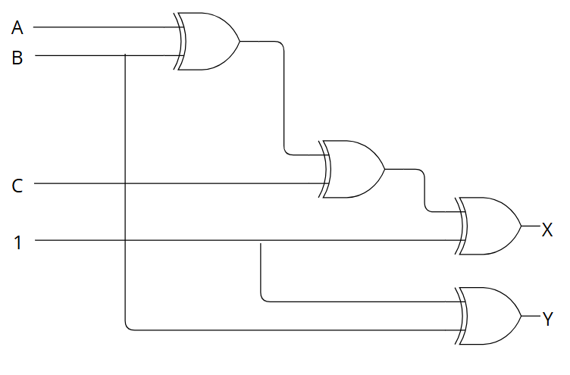
Figure 1: Logic diagram of X and Y
The circuit is implemented in Quartus II to simulate and compare to the truth table. The following circuit schematic is drawn:
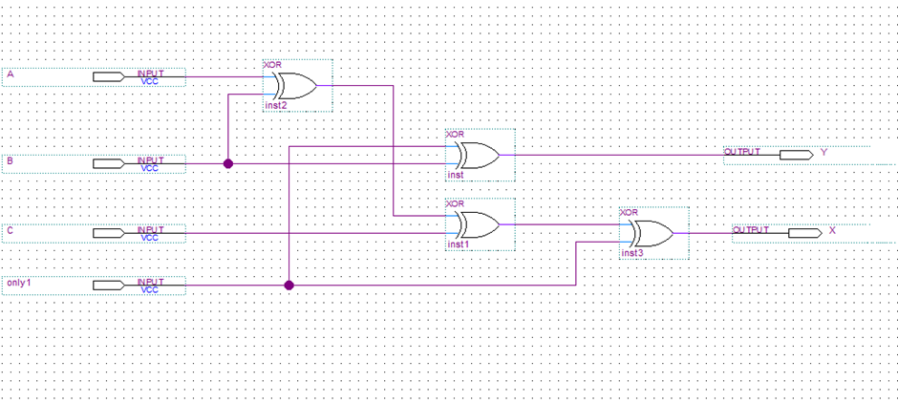
Figure 2: Quartus II schematic of the Incrementor/Decrementor circuit
This circuit is simulated and the following results are obtained:
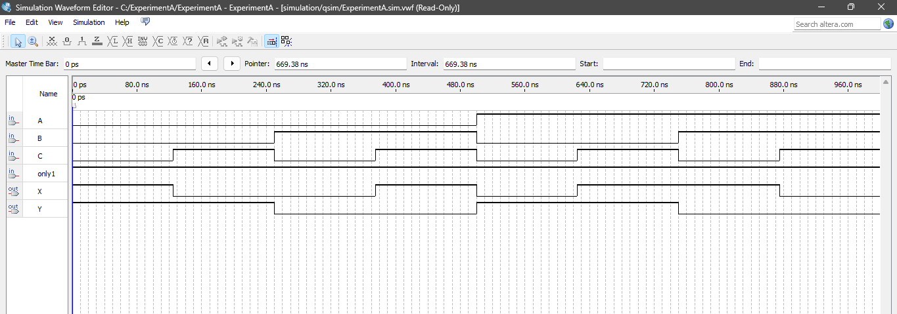
Figure 3: Quartus II simulation of the Incrementor/Decrementor
Observing the simulation results, and comparing them to the truth table filled at the start of the experiment, it can be seen that the results are the same. For example, for A=1; B=0; C=1 X=1; Y=1 in the simulation, which is the same as in the truth table.

- In the experiment, this system was implemented on the breadboard, the ground pin of the 74LS86 was connected to the ground in the analog digital trainer. The IC was energized by connecting the 5V supply from the analog digital trainer to the VCC pin of the IC. The inputs A, B, and C were taken from the DIP switches, and the output were connected to the LEDs in order to validate the system.
The circuit was tested for all input combinations, and the results were observed to be analogous to the results of the Quartus II simulation, and the outputs in the truth table.
- The following is a diagram of the IC, input, and output connections made, to implement the Incrementor/Decrementor:
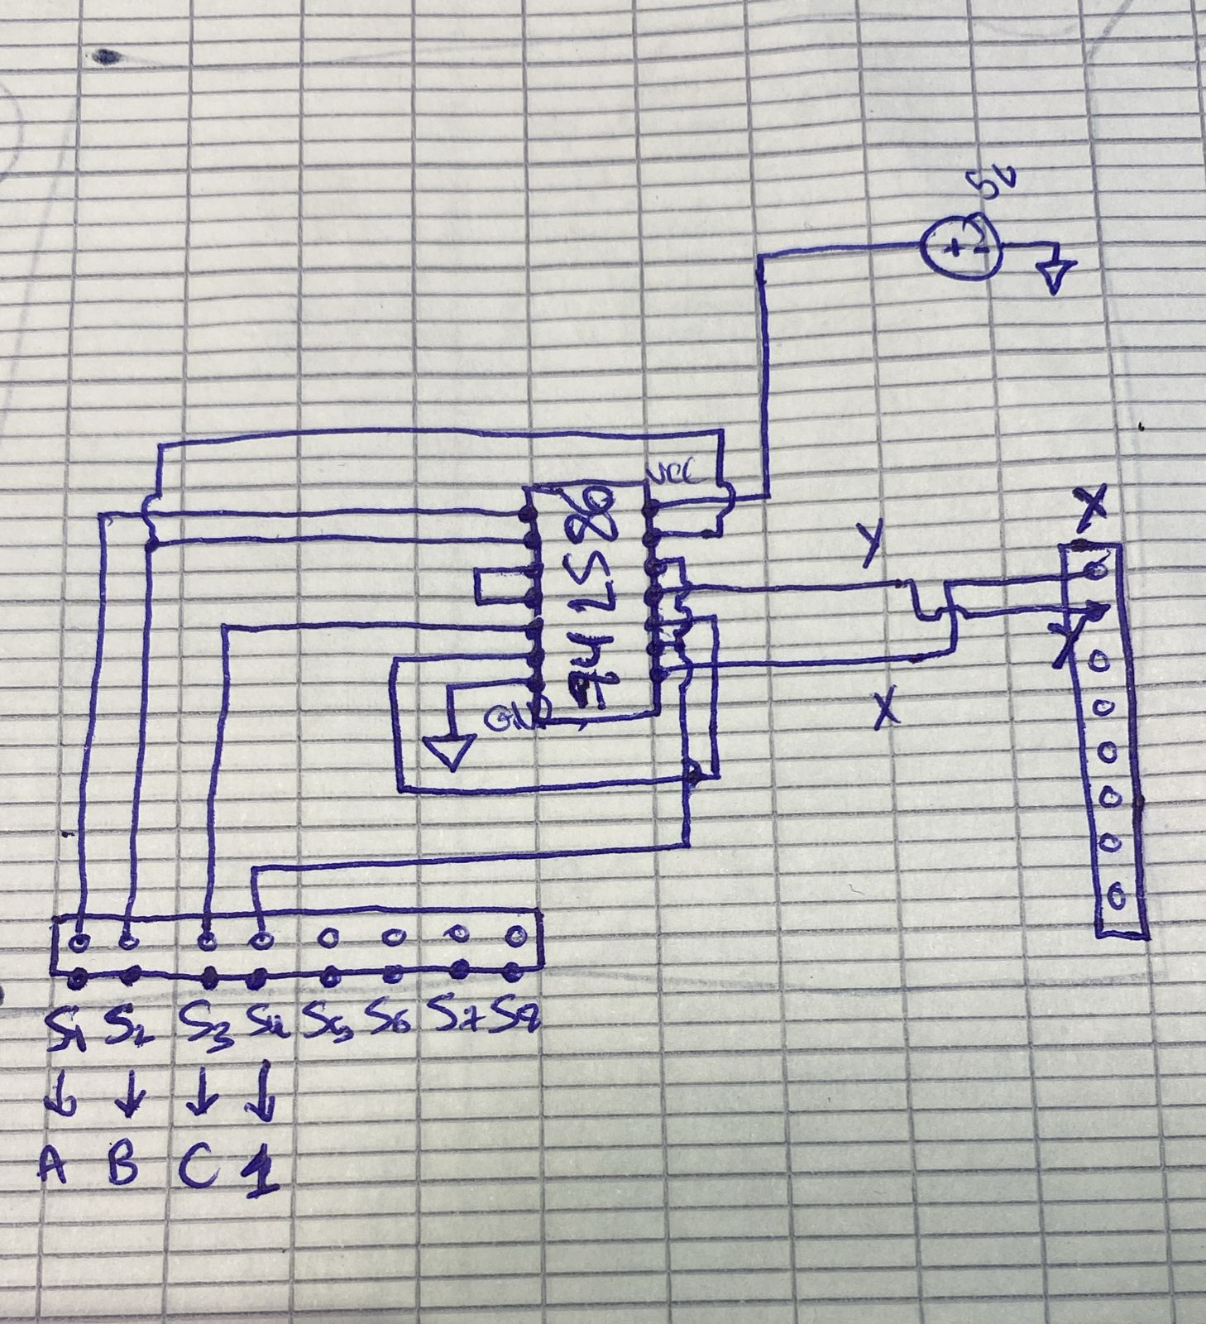
Figure 4: Incrementor/Decrementor Diagram

B - Implementing a Teacher Grading System
In this part of the experiment, we were asked to implement a program for a schoolteacher that aims to determine the final grade of students. The exam is out of 10 points, and the passing grade is 5/10.
The teacher does not like odd grades, so they decide to decrement all odd grades to the closest even number. However, they are not allowed to fail a student who originally had a passing grade. The initial grade of the student is used as the input to the system, which will then output the modified final grade.
In addition, the teacher needs a signaling lamp to notify them whenever the initial grade is modified. A Green LED light indicates an unchanged grade, and a Red LED light indicates an adjusted grade.
Here is the truth table representing the grading system with the resulting output:
Table 6: Truth table of the grading system
A | B | C | D | A₁ | B₁ | C₁ | D₁ | X
0 | 0 | 0 | 0 | 0 | 0 | 0 | 0 | 0
0 | 0 | 0 | 1 | 0 | 0 | 0 | 0 | 1
0 | 0 | 1 | 0 | 0 | 0 | 1 | 0 | 0
0 | 0 | 1 | 1 | 0 | 0 | 1 | 0 | 1
0 | 1 | 0 | 0 | 0 | 1 | 0 | 0 | 0
0 | 1 | 0 | 1 | 0 | 1 | 0 | 1 | 0
0 | 1 | 1 | 0 | 0 | 1 | 1 | 0 | 0
0 | 1 | 1 | 1 | 0 | 1 | 1 | 0 | 1
1 | 1 | 0 | 0 | 1 | 1 | 0 | 0 | 0
1 | 0 | 0 | 1 | 1 | 1 | 0 | 0 | 1
1 | 0 | 1 | 0 | 1 | 0 | 1 | 0 | 0

Then, we are asked to implement the circuit on breadboard using the minimum number of ICs. To do so, we start by finding the equations for A₁, B₁, C₁, D₁ and X:
After analyzing the truth table, it was observed that the upper bits (A, B, C) remain unchanged under the grading constraints, then
$$A_{1}=A$$
$$B_{1}=B$$
$$C_{1}=C$$
In order to find D₁, we start by drawing its K-map:
Table 7: K-map of D₁
AB\CD | 00 | 01 | 11 | 10
00 | 0 | 0 | 0 | 0
01 | 0 | 1 | 0 | 0
11 | X | X | X | X
10 | 0 | 0 | X | 0

We deduce that $D_{1}=BC^{'}D$
In order to find X, we draw its K-map:
Table 8: K-map of X
AB\CD | 00 | 01 | 11 | 10
00 | 0 | 1 | 1 | 0
01 | 0 | 0 | 1 | 0
11 | X | X | X | X
10 | 0 | 1 | X | 0

We deduce that $X=B^{'}D+CD=D\left(B^{'}+C\right)$
The circuit has been designed using the minimal number of ICs of 2 74LS00, using 7 NAND gates as displayed in the following design:
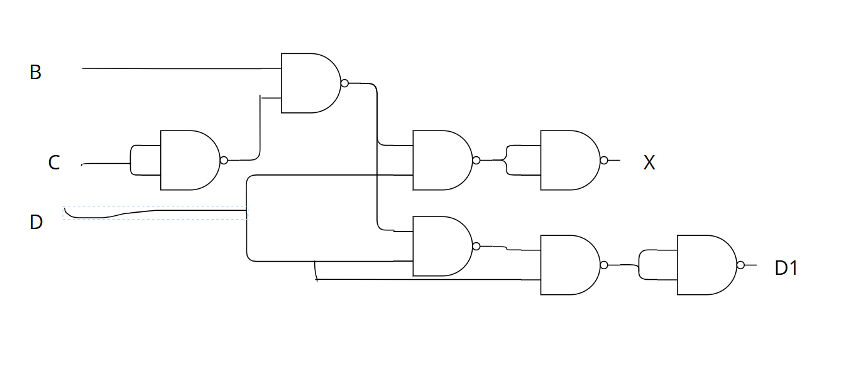
Figure 5: Circuit diagram of the grade calculating program

C - Building our grading system in a Quartus II project
We set up the inputs of the grades represented by the 4 bits A,B,C, and D and the grade after being processed to A1, B1, C1, and D1. X is the indicator that will flag a change to the grade where it turns green when it’s of value 0 and red when 1.

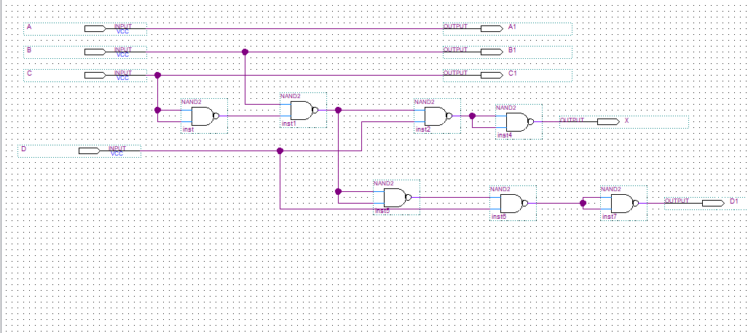
Figure 6: Implementation of experiment B

We then simulated the design taking into consideration all the possible grades up to 10
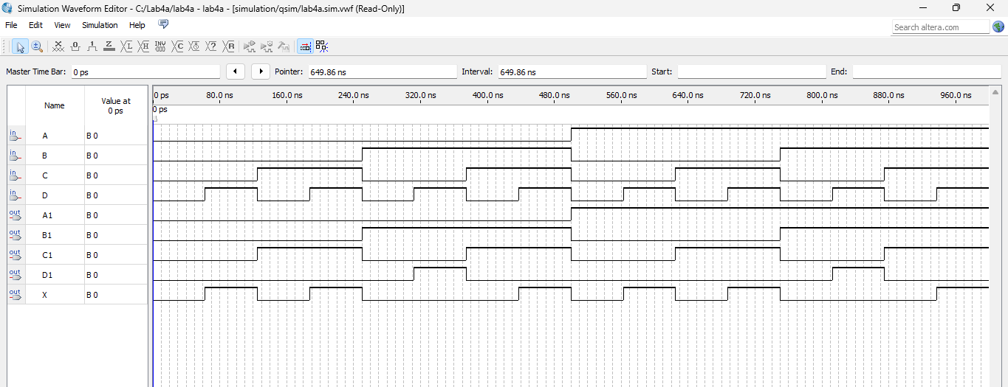
Figure 7: Successful simulation of the design

V – Theory
- In this exercise, we are required to design a grading system from 0 to 20 that changes odd numbers into even numbers by subtracting 1. The system must not fail a student if they already have a passing grade. In the case of grades from 0 to 20, the passing grade is 10, which is already an even number. Here is the truth table of the system:
Table 9: Truth table for grading system from 0 to 20
A | B | C | D | E | A₁ | B₁ | C₁ | D₁ | E₁ | X
0 | 0 | 0 | 0 | 0 | 0 | 0 | 0 | 0 | 0 | 0
0 | 0 | 0 | 0 | 1 | 0 | 0 | 0 | 0 | 0 | 1
0 | 0 | 0 | 1 | 0 | 0 | 0 | 0 | 1 | 0 | 0
0 | 0 | 0 | 1 | 1 | 0 | 0 | 0 | 1 | 0 | 1
0 | 0 | 1 | 0 | 0 | 0 | 0 | 1 | 0 | 0 | 0
0 | 0 | 1 | 0 | 1 | 0 | 0 | 1 | 0 | 0 | 1
0 | 0 | 1 | 1 | 0 | 0 | 0 | 1 | 1 | 0 | 0
0 | 0 | 1 | 1 | 1 | 0 | 0 | 1 | 1 | 0 | 1
0 | 1 | 0 | 0 | 0 | 0 | 1 | 0 | 0 | 0 | 0
0 | 1 | 0 | 0 | 1 | 0 | 1 | 0 | 0 | 0 | 1
0 | 1 | 0 | 1 | 0 | 0 | 1 | 0 | 1 | 0 | 0
0 | 1 | 0 | 1 | 1 | 0 | 1 | 0 | 1 | 0 | 1
0 | 1 | 1 | 0 | 0 | 0 | 1 | 1 | 0 | 0 | 0
0 | 1 | 1 | 0 | 1 | 0 | 1 | 1 | 0 | 0 | 1
0 | 1 | 1 | 1 | 0 | 0 | 1 | 1 | 1 | 0 | 0
0 | 1 | 1 | 1 | 1 | 0 | 1 | 1 | 1 | 0 | 1
1 | 0 | 0 | 0 | 0 | 1 | 0 | 0 | 0 | 0 | 0
1 | 0 | 0 | 0 | 1 | 1 | 0 | 0 | 0 | 0 | 1
1 | 0 | 0 | 1 | 0 | 1 | 0 | 0 | 1 | 0 | 0
1 | 0 | 0 | 1 | 1 | 1 | 0 | 0 | 1 | 0 | 1
1 | 0 | 1 | 0 | 0 | 1 | 0 | 1 | 0 | 0 | 0
It is clear that the output $A_{1}=A$,$B_{1}=B$,${ C}_{1}=C$,$D_{1}=D$, $E=0$ and $X=E$.
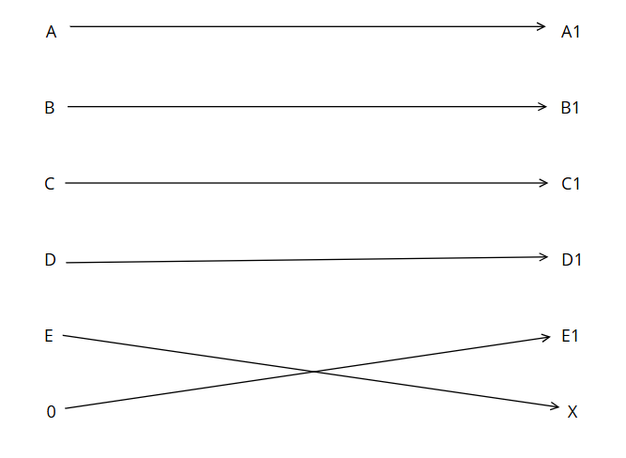
Figure 8: Circuit diagram of the grade calculating program from 0 to 20

- The relation between an incrementor’s input and its output can be generalized to implement an n-bit incrementor. Assuming the input of an n-bit incrementor is an n-bit number: $A_{n-1}A_{n-2}…{A_{1}A}_{0}$
And the output is of the form: $S_{n-1}S_{n-2}…{S_{1}S}_{0}$
Then, to find the output, find the least significant zero, invert it to 1, and invert all 1s before it to zeroes. The 1 added could be considered $C_{o}$, the input carry, and each bit can be determined by the addition of the carry with the input bit at the same position. This can be presented as:
$$C_{0}=1$$
$$C_{i+1}=A_{i}C_{i}$$
As for the output bits Si:
$$S_{i}=A_{i}⊕C_{i}$$

VI – Conclusion
This experiment demonstrated the concepts of Incrementation and Decrementation and their implementation in logic circuits. Specifically, this experiment consisted an implementation of a 2-bit Incrementor/Decrementor, and a teacher grading system that uses Decrementation. Both systems were analyzed logically and theoretically, then the output equation of each were derived, to be followed by actual circuit implementation using logic gates. Moreover, results were confirmed through Quartus II simulation. In conclusion, this experiment introduced complex logic circuits through the 2 two systems built, and enhanced skills of logical analysis, boolean simplification and manipulation, implementation through universal gates, circuit simulation, and actual circuit building.

